

**TRESTLE BOARD**

**TABLE ROCK LODGE #680**

**Located at 54 Kimberling Blvd.**

**Mailing address: P. O. Box 461, Kimberling City, MO 65686**

**Website** [**www.tablerocklodge.org**](http://www.tablerocklodge.org)

**WB Rob Fuqua, Worshipful Master WB Larry J. Dreppard, Secretary**

**14 Midview Drive P. O. Box 93**

**Kimberling City, MO 65686 Lampe, MO 65681**

**417-739-9877 417-336-8306**

[**fuquarj@gmail.com**](mailto:fuquarj@gmail.com)[**larryjdreppard@yahoo.com**](mailto:larryjdreppard@yahoo.com)

**March 2013**

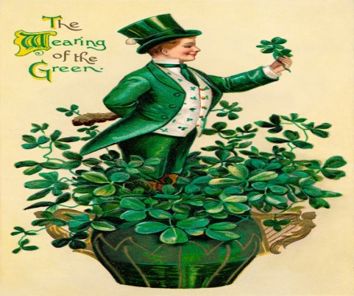

**FROM THE EAST:**

Table Rock Lodge #680 was well represented at the Branson Lodge Hall on **February 23rd**  Masonic Home Seminar held for Masons and Mason’s Widows and Eastern Star. Brothers Larry Dreppard, Chuck Pittman, John Johnson and their wives, Ed Verrill and Rob Fuqua enjoyed a great luncheon. Local Branson entertainers and an informative presentation by Rhonda Lightfoot from the Masonic Home was given. Information on the Masonic Home will be available in the Lodge.

I want to thank Brothers Glen Rosenburg, Harry Mackey, Carl Jeschke and Kenny Adkins for their continued presence and help at Lodge Practice. Brother Howard Lance White dropped in to see us. Brother White has been in North Dakota and Colorado for the last several months and is now on his way back to work in Colorado. He wanted to make sure that his best regards was given to all the brothers.

Worshipful Master Tony Root did a great job in his Funeral Presentation at Brother Harvey Stephenson’s Funeral ably assisted by Brothers Glen Rosenburg, Chuck Pittman and Fred Ybarra, February 25, at the Kimberling City United Methodist Church. Brother Root’s presentation was punctuated with timely retorts of thunder and flickering of the church lights. The Lodge was well represented by many brothers.

Lodge meeting was cancelled due to a long standing policy that if Reeds Spring School District is closed on the day of Lodge meeting then the lodge will be closed. I think that has never happened in the seven years that I have been in Lodge. As I plowed the snow from my driveway and watched the traffic go by on some of the major roads in Kimberling City, I pondered our policy. However with the parking lot at the Lodge not paved and the snow being deep from the last snow with an ice bank on the sidewalk on the north side of the building I begin to believe that our policy about closing is a good policy. Now that I am inside and my back muscles are beginning to tighten-up and knowing that later tonight the roads may become frozen and treacherous it is a good policy. Hopefully, all will be safe for the brothers tonight. See you at Lodge **March 12th**  or sooner at some of the events at the Lodge.

Fraternally,

Rob Fuqua, Worshipful Master

**C:\Users\Larry\AppData\Local\Microsoft\Windows\Temporary Internet Files\Content.IE5\BVENO4I9\MC900442036[1].wmf**

**PLEASE MARK YOUR CALENDARS FOR THE FOLLOWING EVENTS:**

**DATE TIME EVENT**

March 1 4:00 p.m. -7:00 p.m. Kimberling Chapter Spaghetti Dinner and Bake Sale

March 5 6:00 p.m. Practice

March 7 Eat 6:00 p.m., Mtg. 7:30 p.m. District School of Instruction – Galena Lodge

**MARCH 10 DAYLIGHT SAVINGS TIME BEGINS**

March 10 8:00 a.m.-1:00 p.m. Pancake Brunch (every 2nd Sunday)

March 12 7:00 p.m. Stated Meeting

March 17th ALL DAY St. Patrick’s Day

March 19 6:00 p.m. Practice

March 26 Eat 6:00 p.m., Mtg. 7:00 p.m. Stated Meeting and Dinner

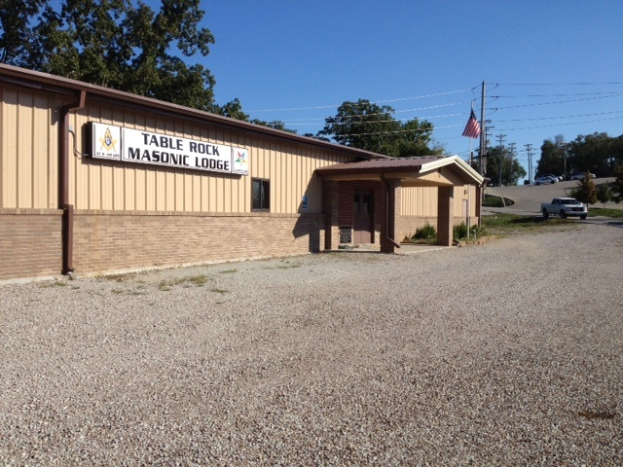

**FROM THE WEST:** Sr. Warden, Brother Kenny Adkins

Brethren we need better attendance to keep our Lodge strong. Please attend the meetings and give us your thoughts and support.

**FROM THE SOUTH:**  Jr. Warden, Brother Glen Rosenburg

You won’t want to miss coming **March 26th**  when a London broil meal including dessert will be prepared by Brother Glen Rosenburg and Rt. Worshipful Brother Chuck Pittman before the meeting at 6:00 .m.

**FROM THE SECRETARY’S DESK:**

**Reminder: Dues are due for 2013. *Endowed Members, Widows and 50 year members are not required to pay dues.***  There are still close to twenty brothers who have not paid their dues for 2013, if your dues are not paid within the next several weeks, you will be suspended, not only from the Blue Lodge, but all other Masonic bodies.

**Lodge Dues $75.00**

***Grand Lodge assessment included in dues.***

**\*\*\*\*\*\*\*\*\*\*\*\*\*\*\*\*\*\*\*\*\*\*\*\*\*\*\*\*\*\*\*\*\*\*\*\*\*\*\*\*\*\*\*\*\*\*\*\*\*\*\*\*\*\*\*\*\*\*\*\*\*\*\*\*\*\*\*\*\*\*\*\*\*\*\*\*\*\*\*\*\*\*\*\*\*\*\*\*\*\*\*\*\*\*\*\*\*\*\*\*\*\*\*\*\*\*\*\***

A District School of Instruction will be presented by DDGL, RWB Chris McLemore at Galena Lodge #515 Galena, MO on **Thursday, March 7th**. We will be practicing opening and closing of the Lodge. Dinner at 6:00 p.m. Lodge opens at 7:30 p.m. Plan to attend.

******************************************************************************************

Don’t forget to support the Kimberling Chapter on **Friday, March 1st** at the Spaghetti Dinner and Bake Sale from 4:00 p.m. -7:00 p.m. The menu will include spaghetti with or without meat sauce, salad, rolls and dessert along with coffee, tea and water for $7.50 for adults and $3.00 for children 3-7.

C:\Users\Larry\AppData\Local\Microsoft\Windows\Temporary Internet Files\Content.IE5\CV7I0267\MC900324594[1].wmf Ya’ll come! **Sunday, March 10th**… 8:00 a.m. -1:00 p.m. Pancakes, scrambled eggs, sausage, hash browns, biscuits & gravy, regular and sugar free syrup, OJ & coffee all for $6.00, children 12 and under $3.00. Bring your family and friends. See you there! Where, well at Table Rock Lodge, of course!

**RAINBOW ASSEMBLY** Rainbowgirlslogo.jpg

March 14 6:30 p.m. Meeting

March 28 6:30 p.m. Meeting – possible candidate for initiation

The Rainbow Girls did a wonderful job waiting on the tables, working in the kitchen and especially assisting the widows at the recent Luncheon held at Branson Lodge. Everyone enjoyed having the young ladies there to help out.

*****************************************************************************************

C:\Users\Larry\AppData\Local\Microsoft\Windows\Temporary Internet Files\Content.IE5\IDSS3USW\MC900055278[1].wmf

A great wind is blowing, and that gives you either imagination or a headache!

Catherine II

From the Historian

No, the Masons have never offered insurance policies to their brothers as some fraternities do.

However, they did have a kind of liability insurance back when the most usual form of tort was to strike off the head of the offender.

From the Edict of Rothari, 643 A.D.

Section 144. **Of the Comacine Master** - If a Comacine Master with his associates (colligantes) shall undertake to restore or build the house of any person whatsoever, after an agreement shall have been closed as to payment, and it chances that someone should be killed, by reason of the house, through the falling of either material or stone, no claim shall be lodged against the owner of the house, in case the Comacine Master or those working with him (consortibus) shall fall to settle for the death or the damage done; because who after having contracted to do work for his own advantage, must assume, not undeservedly, the damage done.

Section 145. **Of masters called or brought in.** - If any person shall call or bring in Comacine Masters one or several - to design a work or to daily assist his retainers (servi) at the building of his house (domun aut casa), and it should happen that, by reason of this house (casa), one of the Comacines is killed, the owner of the house (casa) shall not be held responsible. On the other hand, if falling timber or stone should kill an outsider or cause injury to anyone, the fault shall not be imputed to the Masters, but to him who called them in, and he shall be responsible for the damage.

The [early medieval](http://webmail1.mail.aol.com/wiki/Early_Middle_Ages) Lombard **Comacine masters** (*magistri comacini*) were stonemasons working in a region of excellent building stone who gave to [Lombardy](http://webmail1.mail.aol.com/wiki/Lombardy) its preeminence in the stone architecture